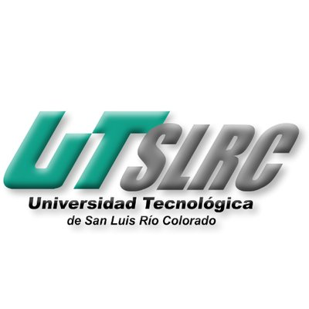

**UNIVERSIDAD TECNOLÓGICA DE**

**SAN LUIS RIO COLORADO**

**CULTURA ORGANIZACIONAL**

**MTRO. VLADIMIR AHMED GALINDO ZENDEJAS**

**AUTOR: VICTOR MANUEL GALVAN COVARRUBIAS**

San Luis Rio Colorado, Sonora Junio, 2020

**CULTURA ORGANIZACIONAL**

**Organizational culture:** norms and values by which a company is governed. Some principles related to the structure of the company, with the methods of execution of the work, and even the way in which the workforce is related.

**Importance:**

This organizational psychology has two areas of action: the internal and the external. This first one has to do with how the company relates to its workers, internal relations, welfare policies, the office's work environment, etc.

Regarding the external level of the organizational culture, it has to do with the entity's behavior towards the outside, its social attitude. It is determined by issues such as its ecological philosophy, if it participates in charitable, governmental and similar activities.

The fundamental values that employees appreciate, generating an impact on morale, motivation, satisfaction and productivity in the company. Therefore, companies must carry out development programs for their employees where the skills of the members of the organization can be developed and improved, strengthening their values and increasing the retention of good employees.

**It is important to maintain the organizational culture because it allows to detect problems in the work groups, or to form teams with a clear and positive ideology for the proper functioning of the company.**